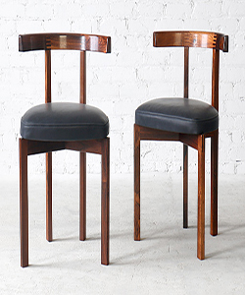

Chairs

$25.02

Availability: In stock

Description

A set of two Danish mid-century chairs by Rosewood furniture. The black color which lighten up the feel of the chairs. The backrest is attached with unique custom brass spherical connectors. We love the curved arm sets, which would fit nicely into any modern dining environment.